Synonyms Antonyms and Homophones
A WebQuest for 2nd Grade (Language Arts)
Designed by
Sabrina Carey
Sabrinacarey5@gmail.com
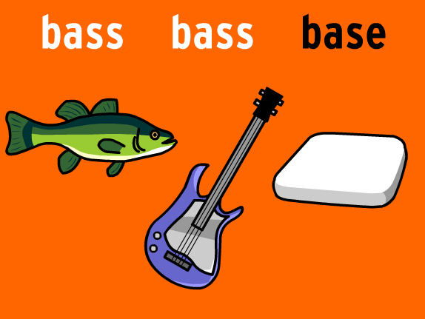
Introduction | Task | Process | Evaluation | Conclusion | Credits | Teacher page

Introduction
Quick I need your help! We need to identify what a synonym is, an antonym and a homophone. Everyone needs to work together with their team in order to accomplish our task today.

So lets get started, click on the start button
Now click on the fish
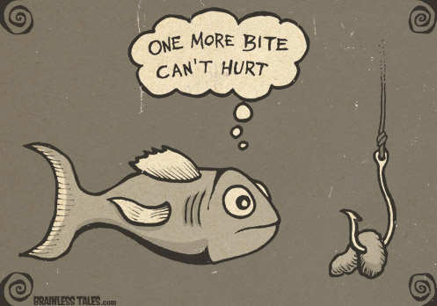
Task
Today you will learn what Synonyms, antonyms, and homophones are. By the end of this WebQuest you will be able to and identify these components and put them into practice by completing 3 different activities, one for each component.

Hear is a quick over view to get your brain moving
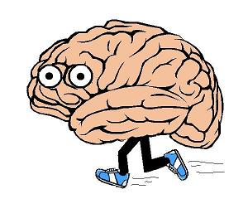

Synonyms:
When identifying synonyms you are looking for words that have similar meanings.
Such as,

Antonyms:
When looking for an Antonym you want to think, “opposites”
Such as,
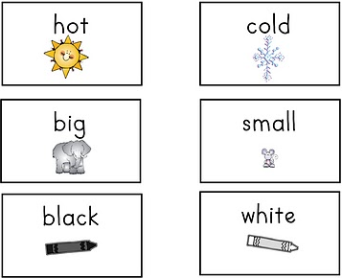
Homophones:
Homophones are words that sound the same but are spelled differently and have different meanings.
Such as,
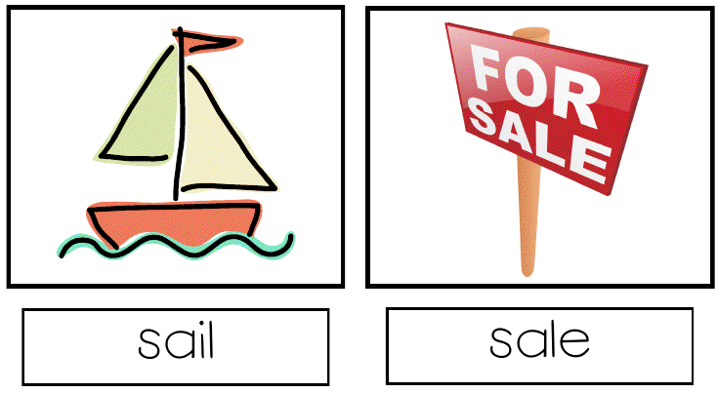
Process
- First break up into groups of three
- Now number yourselves off starting with one (1,2,3) Each person will get a chance to navigate, write, and ask questions.
- Now start with Goal one, make sure to take your time and work together as a group!
Task 1: Synonyms
Ok person #1 your first, you get to navigate through the websites. Person #2 you will be the writer and person #3 you will ask any questions your group has to the teacher.
- Lets learn a little bit more about synonyms click on the synonym for Hot.

Warm Cold Soup

- Time to practice your skills, are you ready!! Click on sponge bob.

Now, click on the link below, print out and complete the blank worksheet. Once you have completed your worksheet check your answers by scrolling down to the bottom of the same page. Make sure if you make any corrections do it in red pen.
Synonyms worksheet

Task 2: Antonyms
Ok person #2 its your turn to navigate, person #3 you will be the writer and person #1 you will ask the question to your teacher (if you have any).
- Click on the Antonym for Dirty, review and practice antonyms.
Filthy Mud Clean
- Alright lets have a little fun and practice your skills before you complete your assignment click on mouse.

Next click on the link below, print out and follow the directions. You will need to take out some scissors and glue for this activity. Once you have successfully completed your assignment check your answers by scrolling down to the bottom of the page. Again if you have to make any corrections make sure you do it in red pen.
Antonym Activity
Task 3: Homophones
Alright person #3 its your turn to navigate, person #1 you are the writer, and person #2 you get to ask the questions (if you have any).
- Click on the telephone to learn about homophones.

- Again let’s sharpen up our skills before we complete our assignment. Click on frog
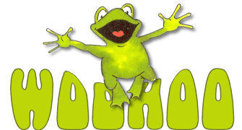
Now lets play a little base ball click on the link and print out and complete the assignment on homophones. After you have completed you sheet check your answers, again if you have to make any corrections do them in red pen.
Homophone Baseball
Now Person #1 takes all three assignments and turns them into your teacher.

Great Job Guys now lets practice all of the components we just learned but lets have a little more fun!!!!
Teacher time
Lets play classroom jeopardy the group you are in now will be your team. Your teacher will use the link below to activate the game. Get ready, which team will be the winner. The winning team will receive extra credit on this assignment.
Classroom Jeopardy

Evaluation
This assignment will be graded as a group project. Students will be evaluated on their ability to recall the information they have learned and work collaboratively.

 | Beginning  1 | Developing  2 | Accomplished  3 | Exemplary  4
Synonyms | After receiving quality instruction and ample practice  Students missed 5 or more questions. on synonym assignment page | After receiving quality instruction and ample practice  Students missed 3-4 questions. on synonym assignment page | After receiving quality instruction and ample practice  Students missed 1-2 questions on synonym assignment page | After receiving quality instruction and ample practice  Students answered all questions correct on synonym assignment page
Antonyms | After receiving quality instruction and ample practice  Students missed 5 or more questions on antonym assignment page | After receiving quality instruction and ample practice  Students missed 3-4 questions. on antonym assignment page | After receiving quality instruction and ample practice  Students missed 1-2 questions on antonym assignment page | After receiving quality instruction and ample practice  Students answered all questions correct on antonym assignment page
Homophones | After receiving quality instruction and ample practice  Students missed 5 or more questions on homophone assignment page | After receiving quality instruction and ample practice  Students missed 3-4 questions on homophone assignment page | After receiving quality instruction and ample practice  Students missed 1-2 questions on homophone assignment page | After receiving quality instruction and ample practice  Students answered all questions correct on homophone assignment page
Collaborative work | Students were not involved and did not participate well with each other. | Students interacted very little with each other and rarely engaged in the assignment | Students worked well as a team, but would often get off task | Students worked well with their team members stayed involved and contributed

Conclusion
Congratulations, you have just finished your assignment! Today you have completed a WebQuest on Synonyms, Antonyms and Homophones. Throughout individualized lessons, games and assignments you have learned what each of these 3 components are, and should be able to identify and give examples of each. If you are still confused or want to go over some of the things you have just learned click the link below:
Help Me!

Credits & References
Classroom jeopardy: http://www.superteachertools.com/jeopardy/usergames/Jan201105/game1296529734.php
Homophone baseball: http://www.superteacherworksheets.com/homophones/homophone-baseball-sentences_WBRMR.pdf
Homophone game: http://www.ezschool.com/Games/Homophones.html
Frog photo: http://kindergartenlifestyle.blogspot.com/2012/01/i-did-it-i-did-it-i-tried-something.html
Yellow phone photo: http://www.clker.com/clipart-4204.html
Homophone lesson: http://www.youtube.com/watch?v=gFUWRqFxtPU&feature=youtu.be
Antonym worksheet: http://www.superteacherworksheets.com/synonyms-antonyms/antonyms-cut-outs_WDWTN.pdf
Antonym game: http://school.eb.com/lm/games/GE_2_6/GE_2_6.htm
Mouse photo: http://orhs.conroeisd.net/cheerleading/home%20page
Antonym Lesson: http://www.studyzone.org/testprep/ela4/h/antonyms.cfm
Synonym lesson: http://www.studyzone.org/testprep/ela4/m/synonyml.cf
Synonym game: http://pbskids.org/lions/games/synsam.html
Sponge bob photo: http://stevejanke.com/archives/241977.php
Homophone picture: http://loryevanspage.blogspot.com/2011/09/homophones.html
Synonym picture: http://ateenytinyteacher.blogspot.com/2011/09/antonyms.html
Running brain: http://www.neurosurgery.ufl.edu/HopeHeels/index.html
Start button: http://www.startrunningforbeginners.com/
Homophone video: http://www.youtube.com/watch?v=K0J-T2lr0Ms&feature=youtu.be
Fish photo: http://www.brainlesstales.com/2007-08-30/one-more-bite-cant-hurt
Synonym and antonym video: http://www.youtube.com/watch?v=jCBB9iahLcw&feature=youtu.be
Synonym worksheet: http://www.superteacherworksheets.com/synonyms-antonyms/synonyms3_WDWTD.pdf

Teacher page

Throughout this WebQuest students will have the opportunity to gain a better understanding on what synonyms, antonyms and homophones are. Once completed students should be able to locate, identify give examples of each. He/ she will also be able to complete activities on their own throughout the WebQuest to show their comprehension. This is a fun interactive way for students to learn one of the fundamental concepts to reading. Once the student understands these key components he/she will understand the proper meaning of words and broaden their vocabulary using different words that mean the same thing.

Standards

This WebQuest is recommended for students in 2nd grade.

Sunshine State Standard / Big Idea:
Standard 6: Vocabulary development- The student uses multiple strategies to develop[ grade appropriate vocabulary.

Benchmark:
LA.2.1.6.7 The student will identify antonyms synonyms and homophones.

